Import the Maven Project in Eclipse IDE

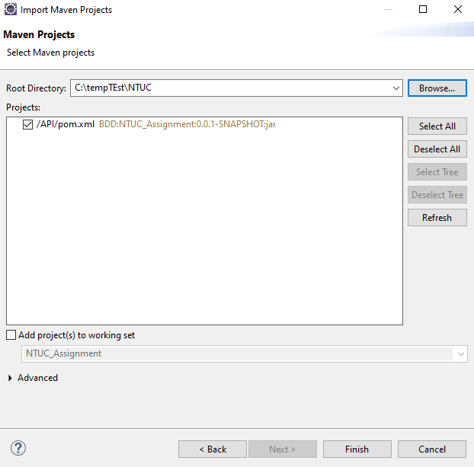

After importing the Maven project in Eclipse, there may be compilation errors as shown below.

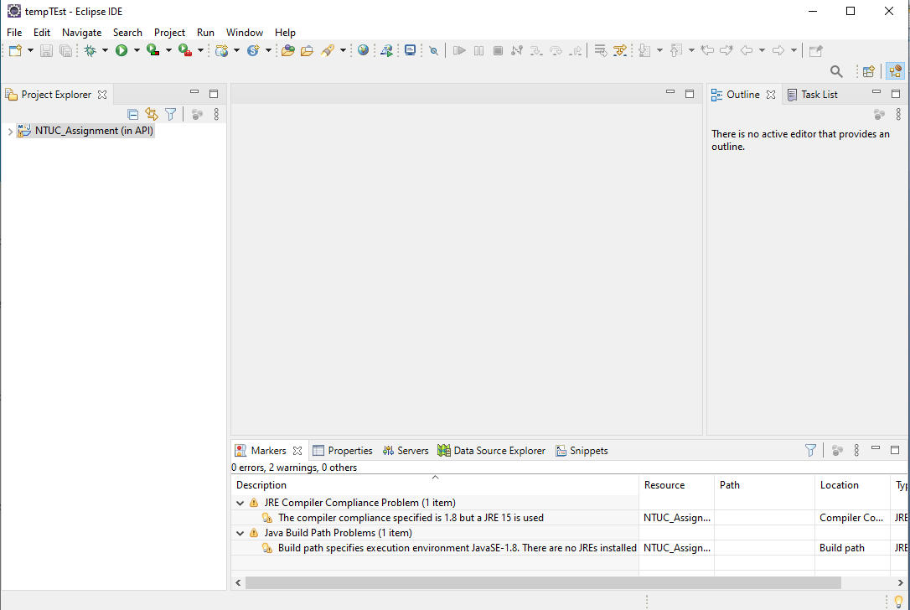

This is due to default Java compiler incompatibility issue in Eclipse (Project is using JDK 1.8, Eclipse default Java compiler is JRE 15 depending on its version).

To resolve the issue, please install JDK 1.8 to the machine where the project is to be run, and then do the followings:

